**Problem Statement:**

**Installing vmware workstation.**

**Solution:**

**STEP 1-** The first step is to download the virtualization software

Download link : <http://www.vmware.com/products/player/playerpro-evaluation.html>

**STEP 2-** The next step is to get a copy of CentOS ISO file

Download link : <http://isoredirect.centos.org/centos/6.8/isos/x86_64/>

**STEP 3-** install vmware workstation

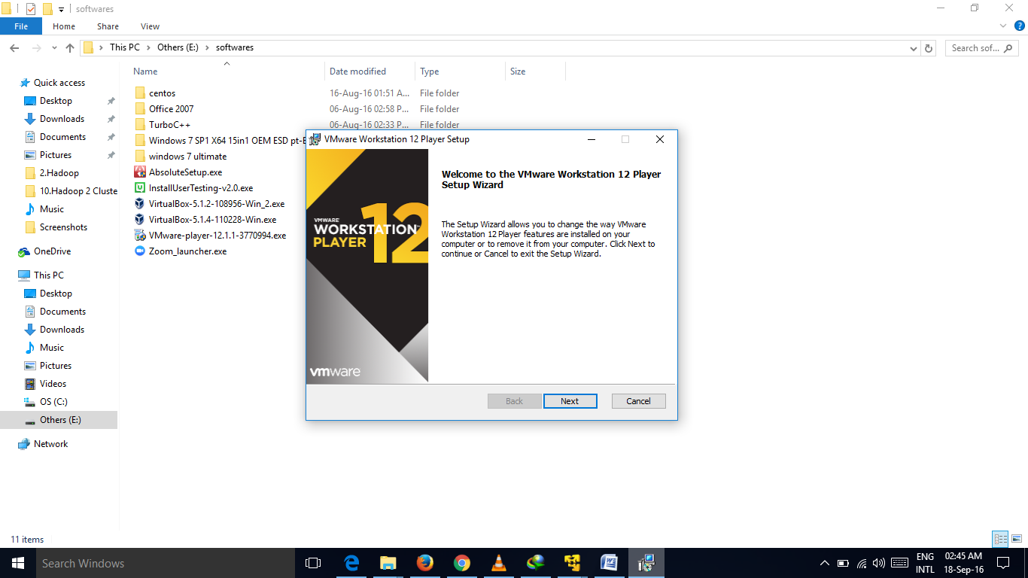

**STEP 4- Install centos**

Click on create a new virtual machine

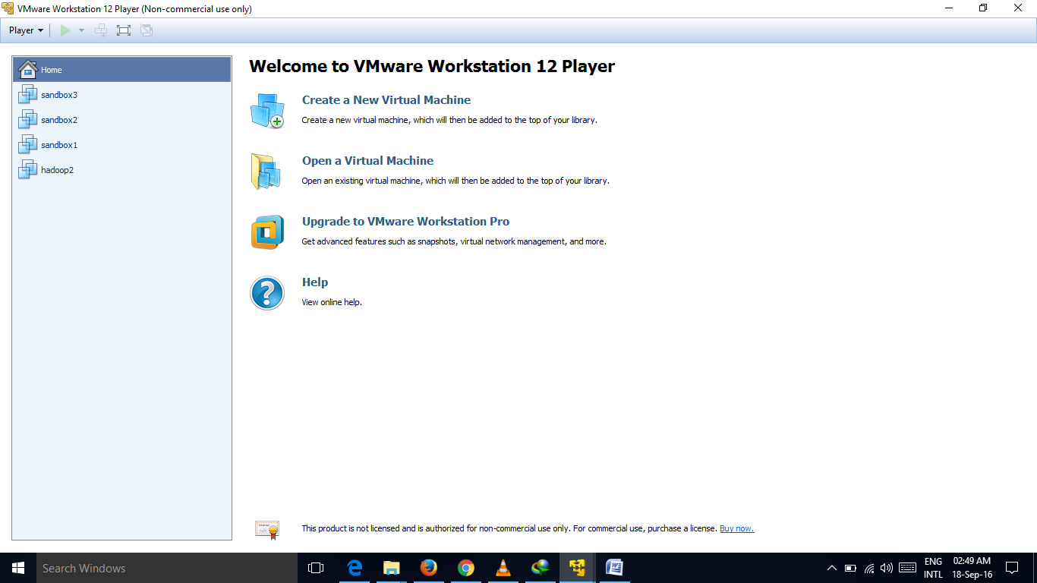

On the next screen choose I will install the OS later.

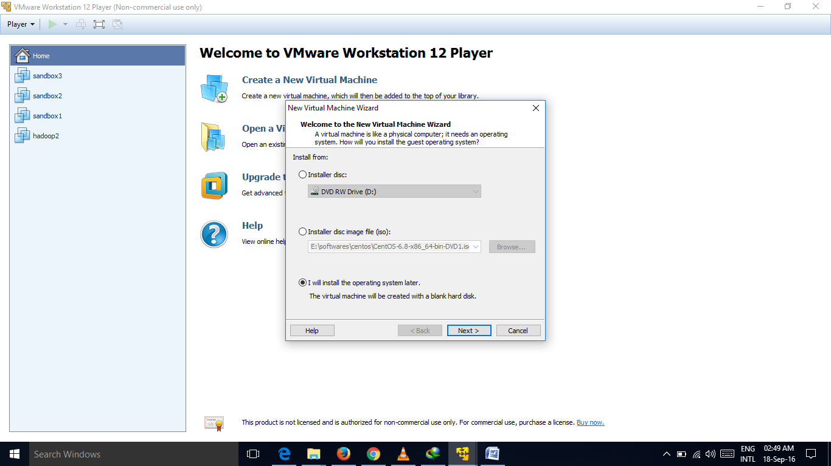

On the next screen, select Linux and Cent OS 64 bit as version

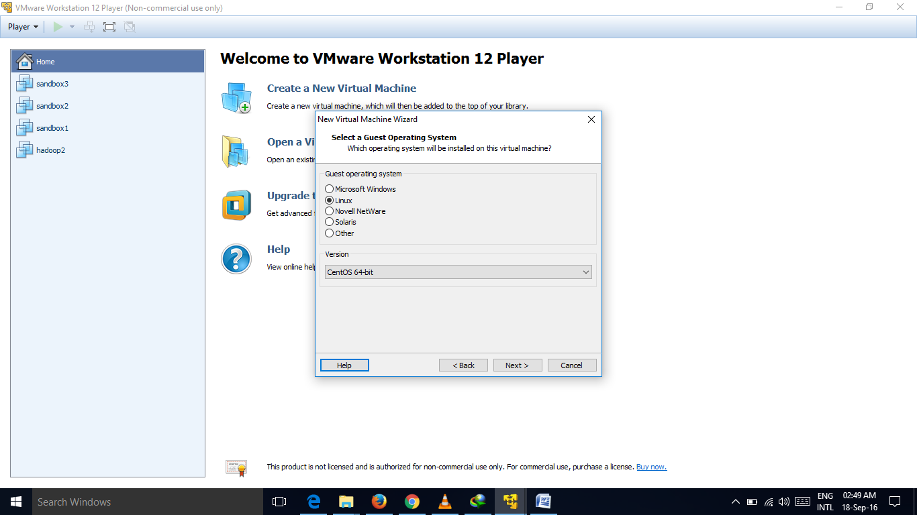

On the next screen give a name “namenode” to our virtual machine.

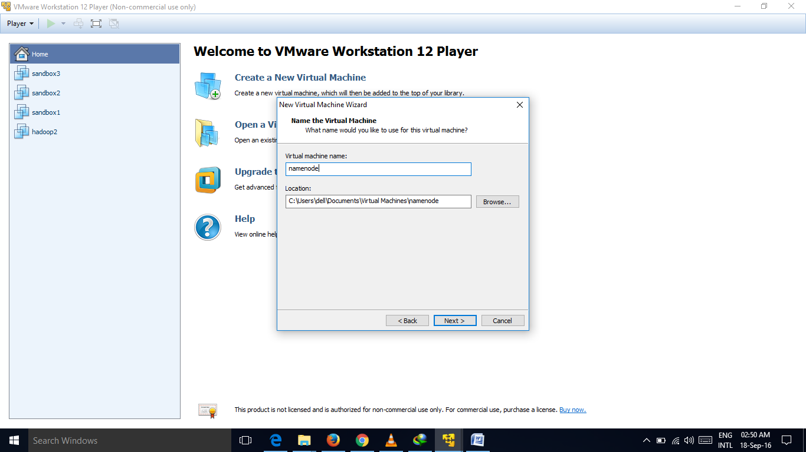

Note – You may want to change the location of the virtual machine as well. By default it will be in C drive.

On the next screen, do not make any changes and click next.

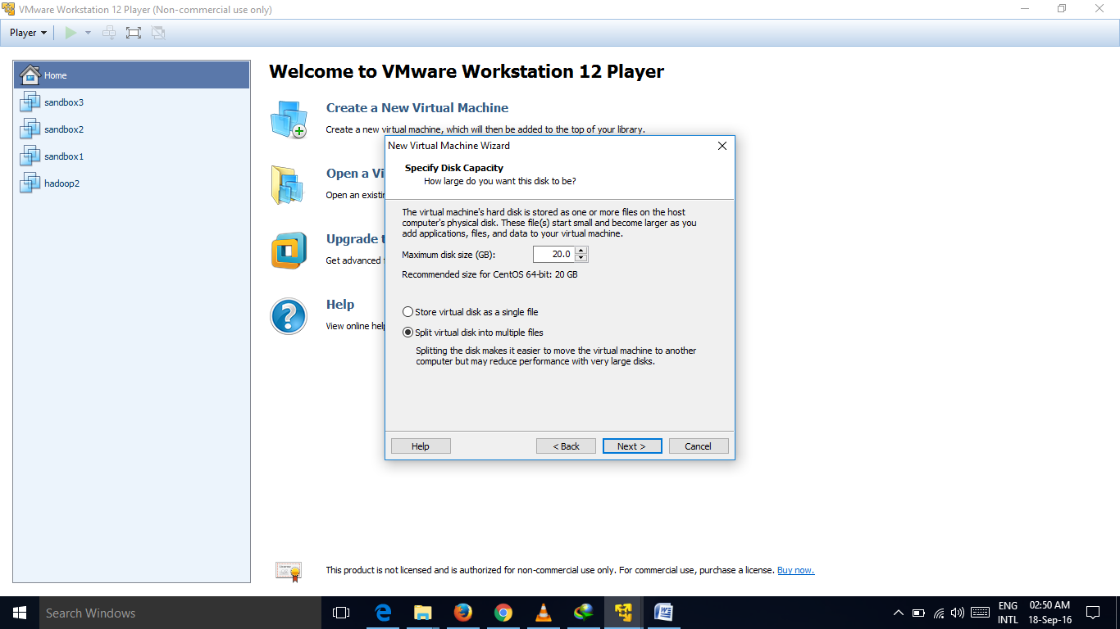

On the last screen, just click finish

If you did well, you will have the namenode virtual machine on the start-up page, as shown below

Now, click on edit virtual machine settings

Click on CD/DVD and select use ISO image. Browse and give the Cent OS ISO file that we have just downloaded.

Click OK. Now we are ready to install Cent OS. Click on Play this virtual machine. The VM will boot from the ISO. The following screen will be displayed.

Choose Skip to cancel the installation media check. But if you choose ok, this will check your installation media for any sort of missing installation files of the operating system.

Now you can see the installation welcome screen. Here click next button.

Now choose the language you prefer to install and click next button.

Choose the appropriate keyboard layout from the option and click next button.

Here choose Basic Storage Device and click next button.

Click Yes, discard any data to continue option in storage device warning.

Type unique host name for this system and click Next button.

Select time/zone and click next button.

Enter strong root password and click next button.

Choose the type of installation. Here I will choose replace existing Linux system(s). You can choose use all space.

Click write changes to disk.

Choose minimal desktop and click next.

The installation will start now.

Click restart once finished.